Help Manual: Commander Version 2.11, 11/21/2015

# Introduction
Welcome to the new client software called Commander for the CruiseEmail network.
Commander allows you to send and receive e-mail using an HF radio and SCS Pactor modem. Commander connects to a shore station gateway over HF radio. The gateway uses the Internet to access your CruiseEmail (CE) e-mail account. While on shore your e-mail is available to you using a web browser.
HF mail systems are much slower than Internet E-mail services. To help alleviate this problem, this new CruiseEmail system allows you to download a list of the messages waiting for you so you can select the messages you want to retrieve over the air. This saves you from wasting air time downloading large messages or unsolicited bulk E-mail (SPAM).

# Key Definitions
Here are some key definitions of terms used in this manual.
Client – Your laptop or computer with the Commander Client Software.
Gateway – The radio, computer and antenna located at a shore station. The gateway sends and retrieves mail from the Internet account.

# System Requirements
- Windows XP, 7, 8.1, or 10
- 2GHz Processor with at least 2 Gigabytes of RAM
- Serial port or serial port adapter

# Registration
Connect to http://www.CruiseEmail.com and fill out the registration form to create an account with CE. Once your account is approved, the CE administrator will activate your account and notify you via your email.

# Download and Installation
Download the client software from www.CruiseEmail.com. Install the software by double left clicking on the downloaded file. The program will open automatically.
Left click on “File”, select “Config”, select “Account” and enter your vessel’s call sign and the password which was furnished to you by the administrator.
Select “Modem” and choose the Gateway to which you wish to connect. Select the “COM Port” to which the Pactor modem is connected. The “COM Port” that is connected to the Pactor can be determined by navigating to Device Manager / Ports.
The initial connection of your client software to a gateway must be done twice, using the “Get List” () command to register the client software with the system and activate your account.

# Client Main Screen
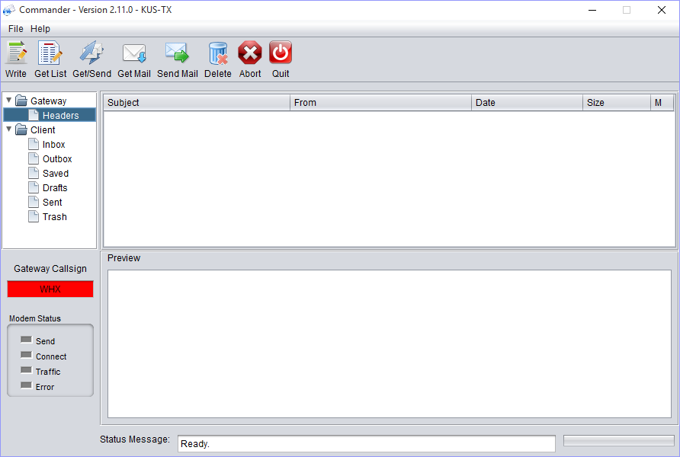

Across the top of the main page are the command button icons.
Left to right as follows:
Write, Get List, Get/Send, Get Mail, Send Mail, Delete, Abort, Quit.
Write: () Click on the mail icon to create an email which contains “To”, addressee; “CC”, copy to; and “Subject” followed by the body of the email.
Get List: () Left click on the “Get List” icon allows you to obtain a list of email on the server which gives you the ability to get “G” or delete “X” email from the server. “G” and “X” indicators are placed in the space provided at the far right of each email header. For example weather reports that are past their usefulness, spam, and junk can be deleted from the server without downloading.
Get/Send: (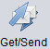) Left click on the “Get/Send” icon to get mail which has been marked for downloading and to send mail which has been posted.
Get Mail: () Left click on the “Get Mail” icon to obtain the emails that have been marked for downloading.
Send Mail: (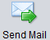) Left click on the “Send Mail” icon to transmit emails that have been posted for sending.
Delete: () Left click on the “Delete” icon to delete the highlighted email from the client.
Abort: () Left click on the “Abort” icon to stop the radio transmission. This is used when propagation is poor on that frequency, and it terminates the transmission so you can switch the radio to a frequency with better propagation.
Quit: () Left click on the “Quit” icon to close the Commander client software.

# Mailboxes
E-mails are accessed and organized in the Folder Pane, which is located on the left side of the program under the command icons. There are two folders, Gateway Folder and Client Folder.
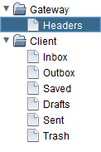
Gateway Folder: A header is the information that shows up with your eMail in the header section. This identifies content in your mail box by Header name only. When you download from the Header command, you create a list of all the stored emails. You then have the ability to delete all mail that you do not want to receive.
# Headers:
On the left side of the client main screen is the Headers tab.
All emails are stored on a central server waiting to be designated for downloading to the client or for deletion without downloading. By storing the emails on a central server, they can be accessed via either the CruiseEmail client or from webmail when you are on shore.
Use of the header tab is a new concept. It will enable you the user to download only the emails you want.
For example, a weather service may send emails many times a day. Vessel owners may not connect for several days rendering much of the weather information no longer relevant. Marking those headers for deletion saves downloading irrelevant information. This methodology applies equally well to SPAM and other undesirable email.
A left click on the “Get List” icon downloads the header information. On the right side of each header place a “G” to get or download the associated email. To delete an email place an “X” in that position.
Afterward when you hit the “Get/Send” or “Get Mail” icon, the server will download emails marked “G” and delete emails marked “X.

Client Folder: This folder holds the various mail boxes, which are located on your computer.
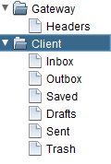
Inbox: This is where downloaded emails are stored on the client.
Outbox: After writing an email, the program will ask you to POST, when you post it sends your message to the outbox which informs the system that email is ready to be sent.
Saved: This is where saved emails are stored on the client.
Drafts: This is where emails under construction are saved. Once the email is finished, it can be posted (see “Outbox” above).
Sent: This is where sent emails are stored on the client.
Trash: This is where deleted emails are stored on the client

# Gateway Call Sign
When a command button is pressed the Pactor will attempt to connect to the gateway with this call sign. The box is color coded to indicate the progress of the session.
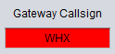
- Red – Disconnected
- Yellow – Connecting
- Green - Connected

# Modem Status Box
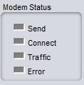
The 'lights' show the status of the Pactor modem.
Send: This light indicates the modem is in the 'send' mode; it is sending traffic to the gateway.
Connect: When this light becomes GREEN, it indicates connection to the gateway shore station.
Traffic Indicator: This indicates that data is being sent.
Error: This indicates that data is not being sent to the gateway. When there is very low signal level, a high level of noise due to propagation, or interference traffic will not pass.

# Status Message Box
This lower portion of the screen will inform you that you have moved your traffic or the type of errors that have occurred, if any.
Special Note: The best way to know that you have a good strong HF/SSB connection to any of our gateways is to be sure before you start, to send a message and click on the “Get/Send” icon. This will trigger the gateway and at the end of the Pactor transmission there will be a CW tone beacon. If you have a good signal, which should be 1-2 bars on your radio in the receive mode, you have a good path for a strong connection to that Gateway station.

# Attachments
Left click the “Write Icon” (), to bring up the “Write Menu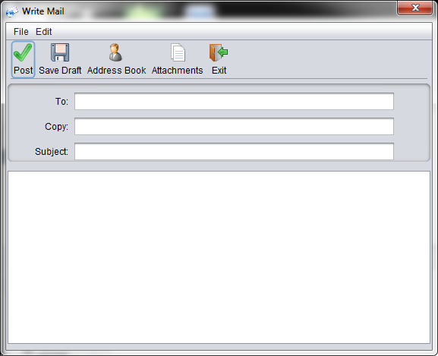

Left click on “Attachments” 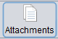 to open the “Attachments” window. 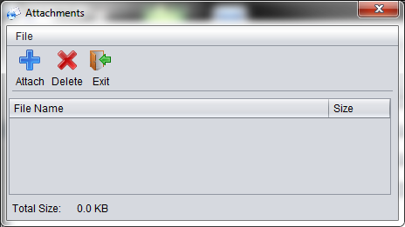
Left click on the “Blue +” 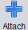 to bring up the “OPEN Window”
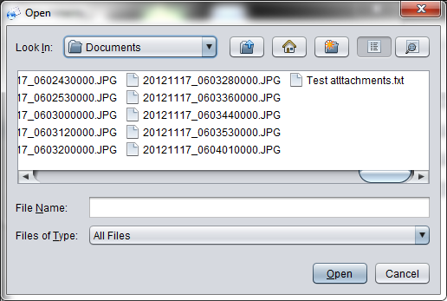
Left click on the document to be attached.
Left click on that document and then left click on “Open” .
Left click on “Exit” 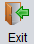
You are now in the “Write Mail” window. You will notice that “Attachments” is highlighted in red indicating there is an attachment on this email.
Click on the “Post” .
Close the “Write Mail” window.
Click on the “Outbox”, where the emails posted for sending are displayed. An (*) asterisk is displayed on the posted email also indicating that the email has an attachment.
Click on “Get Send” 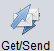or “Send Mail” 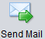to transmit the email. Make sure the frequency is clear prior to transmitting.

